Tech Tests

Contents

Project Proposal 1

Goals and Objectives 1

Project Scope 1

The extent of this venture is to assist individuals with associating with tech tests and to realize mindfulness the most well-known and requesting tests. 1

Project Specifications 1

Target Audience 1

Task List 1

Resource Requirements 3

Project Assumptions 3

Analysis Report 3

Requirements Analysis 3

Detail Design 4

Home Page 4

Login Page 4

Admin Meetup Page 5

Admin Meetup Registration Page 6

Admin Participant Page 7

User Meetup Page 8

User Participation Page 9

User Participation Confirmation Page 9

User Manual 10

Admin Setup 10

User Access Levels 10

Final Project

# Project Proposal

## Goals and Objectives

The fundamental point of this venture is to build up an online web application called "Tech Register for tests" With the assistance of the web application client can enrol for tests around and can take an interest in different tests and can check their subtleties, for example, for which tests they are enlisted. New Users can enlist to get to the register for tests. Also, administrator can include new tests, alter and erase the current tests. Additionally, administrator can erase enlistment and can get to the subtleties of enrolments. Administrator has option to alter, erase and get to subtleties of the members for the tests.

## Project Scope

## The extent of this venture is to assist individuals with associating with tech tests and to realize mindfulness the most well-known and requesting tests.

## Project Specifications

* Admin can login/logout successfully.
* Valid username and passwords are allowed
* Admin can add, edit, delete tests.
* Admin can edit, delete and access details of participants
* Admin can delete and access the registration.
* User can login/logout successfully,
* New User can register successfully
* User can participate in tests
* User can register for tests and check details of the tests.
* Admin can register new admin.

## Target Audience

Users who are keen to know more about new technologies are the target audience for the project.

## 

## Task List

|  |  |  |  |  |  |  |  |  |  |  |  |  |  |  |  |
| --- | --- | --- | --- | --- | --- | --- | --- | --- | --- | --- | --- | --- | --- | --- | --- |
| **Stages** | **Activities** | **Duration**  **Week1-2** | | | | **Duration**  **Week-2-3** | | | | | **Duration**  **Week-3-4** | | | | |
| Project Planning | Research on technologies |  |  |  |  |  |  |  |  |  |  |  |  |  |  |
| Start of Meeting |  |  |  |  |  |  |  |  |  |  |  |  |  |  |
| Project Proposal and documentation |  |  |  |  |  |  |  |  |  |  |  |  |  |  |
| Project Execution | Database Design |  |  |  |  |  |  |  |  |  |  |  |  |  |  |
| User Interface Design |  |  |  |  |  |  |  |  |  |  |  |  |  |  |
| Identity Framework implementation |  |  |  |  |  |  |  |  |  |  |  |  |  |  |
| Admin Interface |  |  |  |  |  |  |  |  |  |  |  |  |  |  |
| User Interface |  |  |  |  |  |  |  |  |  |  |  |  |  |  |
| Testing |  |  |  |  |  |  |  |  |  |  |  |  |  |  |
| Final | Documentation and final report |  |  |  |  |  |  |  |  |  |  |  |  |  |  |

## Resource Requirements

Following technologies and development method:

* Asp.net MVC Framework and Identity framework- ASP
* Windows Operating System, 64-bit Processor and 4 to 8 GB RAM, MS Word

## Project Assumptions

Coming up next are the distinguished elevated level dangers that may influence the consummation and achievement of the venture:

• Cascading delays in other based errands can cause venture delays.

• The size and length of the venture might be thought little of.

• Exceptional gadget assurance ought to be given to the organization, which incorporates private data.

• All out required functionalities can go past what the architect can deliver in the accessible time.

# Analysis Report

### Requirements Analysis

The requirement analysis covers the functional and non-functional aspects of the system.

#### Functional and Non-functional Requirements

|  |  |
| --- | --- |
| **Functional Requirements** | **Non-Functional Requirements** |
| Login/ Logout | The web app should work in all browsers and devices |
| tests add, update, edit, delete check detail as admin | Performance and load time should be fast |
| Registration delete and access by admin | Web app should be secure |
| Participants edit, delete and access by admin | Admin should have full access to the system |
| User can login/logout | Normal user should have limited access to the system. |
| User can register for tests and check details |  |

## Detail Design

### Home Page

This is main landing page of the Web application. On the Navigation bar of this page there are menu options such as Home, Register for tests, Sign up Participants, Register a Meetup Admin and Login.

### Login Page

This Page is helpful for both Admin and users to login to the application by using their credentials.

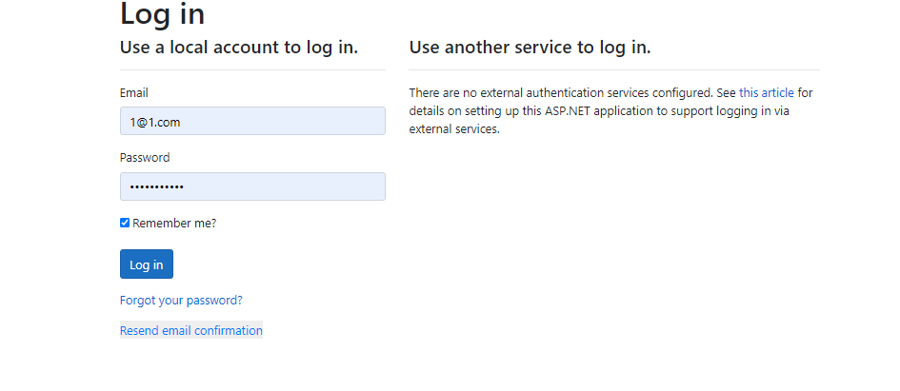

### Admin (user Detail Page)

This page is for admin to create, update and delete any user.

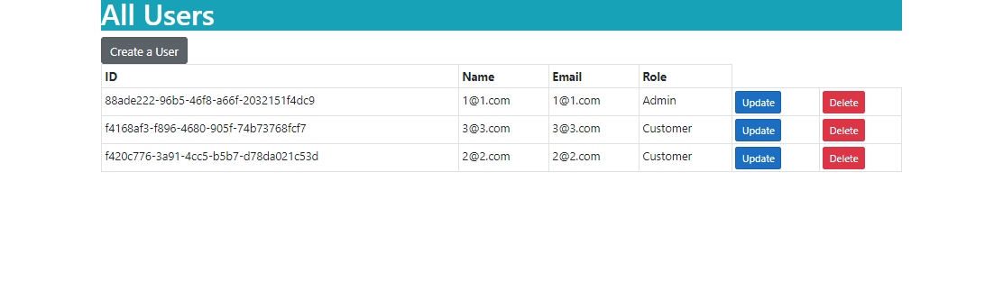

### Admin (Test Page)

Admin can create, update and delete any tests.

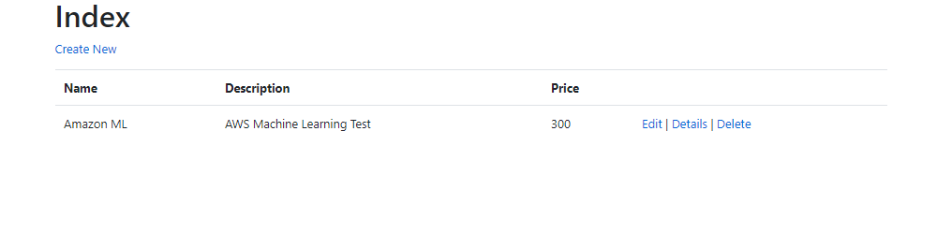

### User (Login Page)

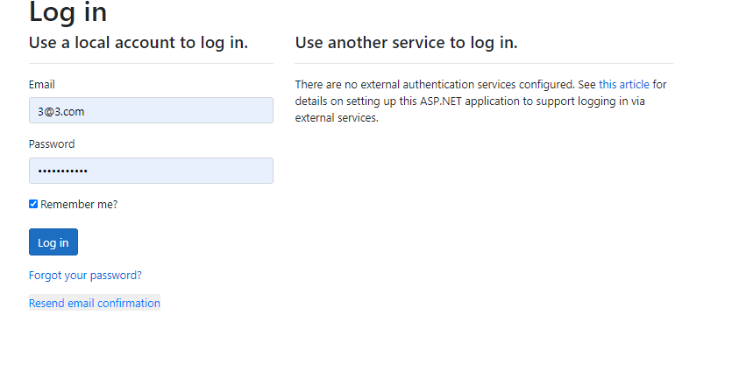

### User (Attendee Page)

This page will highlight the details of the tests and user can confirm the participation for test.

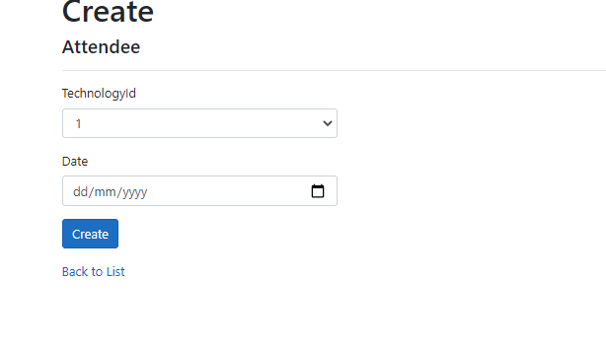

# User Manual

In “Tech Register for tests” web app user can register for tests around and can participate in various tests and can check their details such as for which test they are registered. New Users can register to access the register for tests. Moreover, admin can add new tests, edit and delete the existing tests. Also, admin can delete registration and can access the details of registrations. Admin has right to edit, delete and access details of the participants for the tests.

### Admin Setup

* Admin needs to login using the valid credentials.
* If need to add a new admin, firstly the existing admin will login and register the new admin.

### User Access Levels

Only registered users can access the features of Meetup Application

* Admin: Full access to the system and all functionalities
* Users: Limited access to the app.